**THE FAMILY**

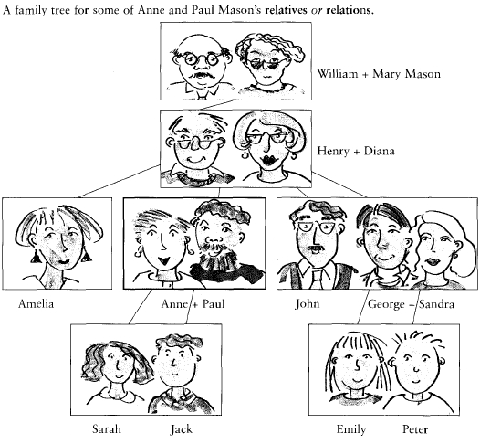

1. Paul is Anne’s HUSBAND.

2. Amelia is Henry’s DAUGTHER.

3. Peter is Emely´s BROTHER.

4. Mary Mason is George´s GRANDMOTHER.

5. Sarah is Paul´s DAUGTHER.

6. Sandra is John´s SISTER – IN – LAW.

7. Jack is William´s GREAT – GRANDSON.

8. Diana is Paul´s MOTHER.

9. Amelia, Paul, John and Jorge are SIBLINGS.

10. Sarah is Emely´s COUSIN.

11. Diana is Amelia´s GRANDMOTHER.

12. Mary is Sarah´s GREAT-GRANDMOTHER.

13. John is Anne´s BROTHER – IN LAW.

14. Sandra is Amelia´s SISTER – IN LAW.

15. William is Paul´s GRANDFATHER.

16. Anne is Amelia´s SISTER – IN - LAW.

17. William is Diana´s FATHER – IN - LAW.

18. Henry is Amelia´s FATHER.

19. Mary Monson is Amelia´s GRANDMOTHER.

20. Sara is William´s GREAT GRAND – DAUGHTER

21. Diana is Sandra´s MOTHER – IN - LAW.

22. William is John´s GRANDFATHER.

23. William is Diana´s FATHER – IN - LAW.

**EJERCICIOS POSESIVO SAJON**

**POSEEDOR + ´S + COSA POSEIDA.**

1. El coche de mi hermano. My brother’s car

2. El coche de mis hermanos. My brothers’ car

3. La habitación de Paul. Paul’s room

4. La casa de Alice. Alice’s house

5. El nuevo teatro de la ciudad The city’s new theater.

6. La boda de Jack y Jill. Jack and Jill’s wedding.

7. La casa del señor y la señora Carter. Mr. and Mrs.Carter’s house.

8. Los días de la semana The week’s days.

9. Los primos de Peter y los primos de Tom Peter’s cousins and Tom’s cousins.

10. Los primos de Peter y Tom. Peter and Tom’s cousins.

11. El talón de Aquiles The Achilles heel.

12. La novia de James. James’s girlfriend.

13. La casa de mis padres My parent’s house.

14. La casa de Mary. Mary’s house.

15. La ropa de los niños. Children’s clothes.

16. La bicicleta de mi padre My father’s bicycle.

17. El trabajo nuevo de John John’s new work.

18. La casa de mis padres My parent’s house.

19. La carne de los Leones The lions’ meat.

20. Este es el lápiz de John ­­­­­­­­­ This is John’s pencil.

21. La Aguja de Cleopatra Cleopatra’s needle.

22. Los hombres del presidente The president’s men.

23. El discurso de la Reina The queen’s speech.

24. La muñeca de Lisa Lisa’s doll

25. Los juguetes de las niñas Girl’s toys

26. La pelota de Diana y Lisa Diana and Lisa’s ball.

27. El coche de los niños Children’s car

28. La cometa de John John’s kite

**SCRAMBLED SENTENCES:**

1. a / fix / mechanic / cars

2. at / the / cry / night / baby

3. east / the / rise / the / in / sun

4. eat / she / breakfast / for / carrots

5. her / children / worry / always / about / she

6. brush / breakfast / his / he / after / teeth

7. speak / students / the / the / classroom / English / in

8. the / carry / MP3 / she / all / player / an / time

9. people / lawyer / a / in / defend / trouble

10. listen / enjoy / Mary / classical / to / music

11. electrical / change / chemical / batteries / energy / into / energy.

12. not many people / they / sixty / before / retire / are

**MAKE WH QUESTIONS:**

**WH+ AUX+S+V(BASE)+C+?**

1. (where / you / go to school?) Where you to go school?

2. (what / you / do?) What you do?

3. (where / John / come from?) Where come from John?

4. (how long / it / take from London to Paris?) ____________________________________________

5. (how often / she / go to the cinema?_ _____________________________________________

6. (how many children / you / have?) _____________________________________________

7. (when / you / get up?) _____________________________________________

8. (how often / you / study English?) _____________________________________________

9. (what time / the film / start?) ____________________________________________

10. (where / you / play tennis?) ____________________________________________

11. (what sports / Lucy / like?) ____________________________________________

12. (how / they / get to work?) ____________________________________________

13. (how often / I / come here?) ___________________________________________

14. (where / she / live?) ___________________________________________

15. (why / you / eat so much chocolate?) ___________________________________________

16. (what / this machine / do?) ___________________________________________

17. (who / she / meet on Saturdays?) ___________________________________________

18. (how many brothers / she / have?) ___________________________________________

19. (how much / this / cost?) ___________________________________________

20. (where / you / eat lunch?) ___________________________________________

**SCRAMBLED SENTENCES WH QUESTIONS**

1. name?./ your/ is/What/ What is your name?.

2. you/live?./ do/ Where/ Where do you live?.

3. old/are/you/How/ How old are you?.

4. do/like?./ What/you/sport/ What sport do you like?.

5. free/ you/ time?./ in/ What/ do/ do/ What do you do in your free time?.

6. swimming?./you/ Do/ enjoy/ Do you enjoy swimming?.

1. a / fix / mechanic / cars - A mechanic fix cars.

2. at / the / cry / night / baby - The Baby cries at night.

3. east / the / rise / the / in / sun - The sun rises in the east.

4. eat / she / breakfast / for / carrots - She eats carrots for breakfast.

5. her / children / worry / always / about / she - She always worries about her children.

6. brush / breakfast / his / he / after / teeth - He brushes his teeth after breakfast.

7. speak / students / the / the / classroom / English / in - the students speak English In the classroom.

8. the / carry / MP3 / she / all / player / an / time – She carries an MP3 player all the time

9. people / lawyer / a / in / defend / trouble - A lawyer defends troubled people.

10. listen / enjoy / Mary / classical / to / music - Mary enjoys listening to classical music.

11. electrical / change / chemical / batteries / energy / into / energy. – Batteries changes chemical energy into electrical energy

12. not many people / they / sixty / before / retire / are – not many people are sixty before they retire